Project 3 - CPU Scheduler
EECE 315
The University of British Columbia
Dept. of Electrical and Computer Engineering

Team Members
Lauren Fung( 100 )
Jorden Hetherington ( 100 )
Jeremy Lord ( 100 )
Rohit Singla ( 100 )

TABLE OF CONTENTS

SECTION | PAGE
1.0 INTRODUCTION
2.0 SOLUTION DESCRIPTION
2.1 Solution Approach
2.2 Development Tools
2.3 Development Methodologies
3.0 DIAGRAMS
4.0 IMPLEMENTATION
4.1 Algorithms Implementation
4.1.1 Algorithm Class
4.1.3 Algorithm Subclasses
4.2 Scheduler Implementation
4.3 Gantt Implementation
5.0 RESULTS AND TEST CASES
6.0 CONCLUSION
APPENDIX A – Source Code
APPENDIX B – Test Code
APPENDIX C – UML Diagrams

1.0 INTRODUCTION

The CPU Scheduler project is a look into one of the fundamental processes in an operating system - the handling and scheduling of processes. By designing and developing a simulator, students achieve an understanding of scheduling algorithms and the benefits and dis-benefits of these algorithms comparatively.

A variety of algorithms are used in scheduling due to different properties they have. For example, a First Come First Serve (FCFS) algorithm may be high in simplicity but low in overall efficiency. On the other hand, a Shortest Previous Job (SPJ) algorithm is significantly more complex, but improves the responsiveness and efficiency of processes. Being able to compare metrics between algorithms run on the same set of processes provides a valuable analytical tool.

This simulator takes in a text file, containing relevant process information, and constructs an initial queue of Process Control Blocks (PCBs). A Scheduler class handles this queue, and runs it through a different algorithm that’s specified at run time. The result is a list of PCB snapshots, ordered in the same way those processes would be run in that algorithm. This means the same PCB identification number is repeated in this list, once for each time it is “run” by the CPU. This list, along with relevant information is sent into a Gantt class, which displays a Gantt chart and shows the appropriate metrics.

2.0 SOLUTION DESCRIPTION

The following sections describe the solution approach, including development tools, development methodology, and supporting references.

2.1 Solution Approach

This project was approached with a modular high-level design, encapsulating relevant parts of the problem. By breaking down the problem into three major classes, Scheduler, Algorithm, and Gantt, developers could work separately and efficiently spend their time. The main function itself was aimed to be kept as simple as possible.

The Scheduler class handles reading the text file and the bulk of user interfacing. It assures that the process text file can be read, it correct, and then passes on the information onto an algorithm. It handles creation of the raw data, and algorithm. Essentially, it separates the creation and the running of algorithms.

The Algorithm class is the black box between initial data and expected output. Based on a variety of parameters, this class determines the overall scheduling order for the processes. It allows all Algorithms to individually run, but make use of similar functions that handle similar jobs for all subclasses. The class hierarchy here enables polymorphism and usage of the Factory creational design pattern. Gantt is then able to take the result of Algorithm and produce analytics and metrics on the resulting order.

2.2 Development Tools

There were a variety of tools used for this project to help with development and for source control. Git was chosen as a version control system in order to manage the source code and to allow developers to work independently. Git was chosen because all of the developers had experience working with it and because it allowed the developers to use a repository on Github. Github was used to host the source code repository for the project. It was chosen to support the open source movement and because of its issue-tracking and wiki features.

All of the developers used their preferred development environment and operating system. The source code was edited with Vim, Gedit and Eclipse and compiled with g++ and Eclipse on Linux, edited and compiled with Visual Studio on Windows and with Xcode on OS X. Skype was chosen to support remote communication when an in-person meeting was not possible.

2.3 Development Methodologies

The development of this project was done in an Agile-like fashion. Many Extreme-Programming practices were utilized in order to complete the project, such as frequent pair programming, and code reviews. A distributed version control system was used. Following good software engineering practices, no changes to master could be made directly - instead, any developments had to be coded, pushed to a unique branch, and then requested for a pull. For any pull request, three of the four developers had to be involved in the changes before the pull was accepted (one developer and 2 approvals), which kept all members of the team aware of the progress of the project. This work was able to be completed asynchronously, and allowed for development of multiple sections to be done simultaneously. To keep track of issues, and advancements in the project, the “issues” section of Github was used. This made it very easy to keep a detailed backlog of items remaining, and display which items were completed. Utilizing these methodologies made for an efficient development process that allowed work to be completed in parallel.

2.4 Supporting References

The CPU scheduling simulator makes extensive use of fundamental C++ libraries. For information on the <algorithm>, <map>, <fstream>, <sstream> libraries, www.cplusplus.com was used. It provided detailed information and definitions. Team members also had a strong knowledge base themselves - two developers had prior experience in the STL which was used extensively.

For the design aspect, and overall hierarchy, Dr. Luis Linares’ lecture notes on CPU Scheduling were used. Additionally, Dr. Abraham Silberschatz’s textbook Operating Systems Concepts provided detailed explanations and clarifications on different algorithms, as well as expected behaviors

3.0 DIAGRAMS

The UML diagram on page (INSERT PAGE NUMBER) of Appendix C demonstrates the interactions and relations between the classes. All the runnable algorithms inherit their member variables and methods from the abstract Algorithm class. However, each of the runnable algorithms override the run() function, which will manipulate a number of ProcessControlBlock objects to suit the needs of that specific algorithm. The Factory class is used to encapsulate the creation of objects belonging to the algorithm subclasses. It is the Scheduler that creates an instance of the Factory class and is then able to use the Factory object to create the algorithm objects. A high-level flowchart can be seen in Figure 1.0 that illustrates the CPU Scheduler Simulator’s life cycle.

The Scheduler class is the main class, as it handles initial parameters, the raw data file, and is responsible for storing the algorithm object to be run and running the algorithm object. The Gantt class makes use of the produced output from the algorithm object. The functions of displaying the Gantt chart and calculating metrics did not make sense to be coupled with the Algorithm and Scheduler classes. Rather, such functions belong in their own class. The chart takes in a container of data and prints out the resulting execution order. It also takes the same container, analyzes it for time variables, and prints out the appropriate metrics for the algorithm that has been run.
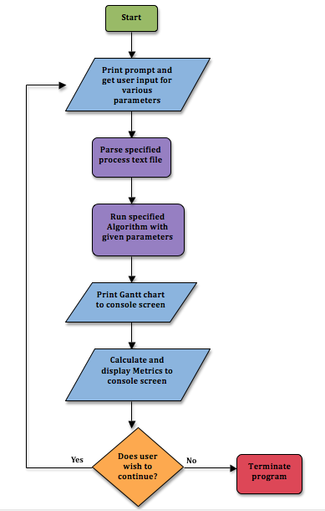
Figure 1.0 - High-level flowchart of CPU Scheduler Simulator’s life cycle

4.0 IMPLEMENTATION

The following sections describe the implementation of the main three classes to the project - Algorithms, Scheduler and Gantt.

4.1 Algorithms Implementation

At the heart of this project are the scheduling algorithms. They determine the final scheduling order for the processes based on information about each process, stored as a vector called _dataInputToAlgorithm. There are several algorithms, which produce different results but have similar implementations. Due to the similarities between the scheduling algorithms, an abstract base class, Algorithm, was created to implement functions that are shared between the algorithms. Each of the algorithms inherits from this base class; this enables polymorphism and allows the use of a Factory object-oriented creation design pattern to create the algorithm objects. Each of the algorithm classes are shown in the table below.

Table 1.0 - Algorithm Descriptions

CLASS NAME | DESCRIPTION
FirstComeFirstServe | Handles the First algorithms – both First Come First Serve and Round Robin
ImpatientPriority | Handles one of the preemptive priority algorithms. This is the impatient version. An executing process can be preempted as soon as a higher priority process enters the ready queue.
PatientPriority | Patient version of the preemptive priority algorithm. Every process gets at least one time slice before being preempted.
NonPreemptivePriority | Handles the non-preemptive priority algorithm. Every process gets to finish its burst without interruption.
NonPreemptiveShortestPreviousBursts | Handles the non-preemptive shortest previous burst algorithm. Keeps a weighted average of past CPU burst times for each process to determine priority.
PreemptiveShortestPreviousBursts | The preemptive form of the shortest previous burst algorithm. It is an impatient preemption.
NonPreemptiveShortestJobFirst | Handles the non-preemptive shortest job first algorithm. Priority for each process is based on its next CPU burst.
PreemptiveShortestJobFirst | Preemptive version of the shortest job first algorithm. It is an impatient preemption.

4.1.1 Algorithm Class

The Algorithm class is the parent of all of the individual algorithms and it contains functions that are common to all of the scheduling algorithms. These functions are described in this section. There are four functions that are common to all of the algorithms and one that is used by all of the impatient preemptive algorithms. The function prototypes are as follows:

- void populateInitialQueues(bool (*predicate)(const ProcessControlBlock&, const ProcessControlBlock&) );

- void passTimeAndCheckWaiting( int time );

- void checkWaitingProcesses( void );

- void sendExecutingProcessToIO( void );

- void preempt(bool (*predicate)(const ProcessControlBlock&, const ProcessControlBlock&) );

The populateInitialQueues function handles splitting up the processes into separate queues. Any process that has a time of arrival of zero (or less) is sent to the ready queue; the others are placed in the time of arrival queue (TARQ). These two queues are members of the Algorithm class (_readyQueue and _TimeArrivalReadyQueue) along with the IO queue (_IOWaitingQueue). When the time of arrival queue is populated, the processes are sorted based on their time of arrival. The ready queue is sorted based on the predicate passed as a parameter. This predicate is a Boolean function that compares two ProcessControlBlock objects and returns true if the first PCB has a higher priority than the second.

The passTimeAndCheckWaiting function simulates the passage of time and handles setting the queues to their correct states after this period of time. It will deduct the time parameter from the time remaining of the IO burst of each process in the IO queue and from the time of arrival of each process in the TARQ. If the new IO burst time or time of arrival of any of these processes is zero or less, the process must be sent back into the ready queue because it has finished its IO burst or it has arrived. Before the PCB is sent to the ready queue, its state is set to READY and its last IO burst is erased because it has completed. Furthermore, this function handles filling the _finalQueueOrder vector with data. This is a vector of AlgorithmData structs; it is used to record information about each CPU burst that can be used by Gantt to display the Gantt chart and the metrics. The AlgorithmData definition follows:

typedef struct AlgorithmData{
int PID;
int burstTime;
int waitTime;
int IOTime;
} AlgorithmData;

This has all of the information needed for Gantt to calculate the metrics for the algorithm. The PID is the process ID of the process corresponding to this CPU burst, the burstTime is the length of this burst, the waitTime is the total wait time of the process up until this burst and the IOTime is the total amount of IO time up until this burst. This structure is filled and pushed to the _finalQueueOrder vector in passTimeAndCheckWaiting because this function is called whenever a CPU burst occurs.

The checkWaitingProcesses function handles the situation when there are processes in the IO queue or TARQ but nothing in the ready queue. It passes time until there is a process in the ready queue by finding the first process in the IO queue or TARQ with the lowest IO burst time or arrival time and then passing that amount of time with a call to passTimeAndCheckWaiting. During this time passage, the CPU is Idle; this data is stored in _finalQueueOrder as an AlgorithmData struct with a PID of -1. If there are no processes in the ready queue when this function returns, it means that all of the processes have terminated.

The sendExecutingProcessToIO function takes the next process in the ready queue, removes its most recent CPU burst, removes it from the ready queue and sends it to the IO queue for its next IO burst. Before it sends the PCB to the IO queue, it sets the state of the PCB to WAITING.

The preempt function is used only by the impatient preemptive algorithms. It searches through the list of PCBs in the IO queue and TARQ queue to find any that will be back in the ready queue before the currently executing process (the PCB at the head of the _readyQueue vector) is finished its CPU burst. It then uses the predicate parameter to determine if the process in the IO queue or TARQ has a higher priority than the currently executing process. If it does, the currently executing process is preempted. To accomplish this, the time at which the currently executing process is preempted is deducted from its CPU burst time. This remaining time is left to be completed once the process regains the CPU. The process, which preempts it is sent back into the ready queue and it takes over the CPU. If nothing preempts the currently executing process, it is allowed to finish its CPU burst.

4.1.2 Algorithm Subclasses

All the algorithm classes inherit from the abstract base class, Algorithm, and override the run() method as well as define their respective constructors. The FirstComeFirstServe subclass takes care of the First Come First Serve algorithm implementation as well as the Round Robin algorithm since the only difference between the two is that Round Robin requires a quantum time to be defined for the time slice. The ready queue is populated based on which process arrives first. The algorithm will then use the breakUpCPUBurst() function to separate the CPU bursts into time slices defined by the user input for quantum time. If First Come First Serve is the algorithm chosen, then no quantum time was specified and each process will run until it needs to go to the I/O queue. After each CPU burst, the algorithm checks if there is a process in the I/O queue that is ready to be moved back to the ready queue. For the First Come First Serve and Round Robin algorithms, if a process returns from the I/O queue, then it is placed at the end of the ready queue and no sorting is necessary. The moving of processes from the ready queue to the I/O queue and back is done through function calls which make use of the push_back() function and .erase() function for vectors.

The other subclasses of the abstract base class, Algorithm, are implemented in a similar way as the First Come First Serve and Round Robin algorithms. The difference is that the size of the ready queue is first saved before the call to the method passTimeAndCheckWaiting(). As this method could possibly have moved a process into the ready queue, the queue could need to be re-sorted. The size of the vector is stored and if, after the passTimeAndCheckWaiting() function call, the ready queue size is equal to or greater than its previous size, then the ready queue is re-sorted based on the needs of the specific algorithm subclass (priority, shortest next CPU burst, or shortest previous CPU bursts).

For algorithms that implement impatient preemption, the function preempt() is used instead of the passTimeAndCheckWaiting() function to move processes into the ready queue. The predicate that is passed to the preempt() function is specific for each of the algorithms. Also, similarly to the non-preemptive and patient preemption algorithms, if the size of the ready queue is equal to or greater than the size of the ready queue after the preempt() function call, the ready queue is re-sorted based on the same predicate that was passed to the preempt() function.

4.2 Scheduler Implementation

The Scheduler class is in charge of handling the interface with the user, and running the specified algorithm. In the main loop of the simulator, a Scheduler object is used to first run a welcome message, then obtain user input, and run the specified algorithm, with the specified data file.

Scheduler has four public methods. The first method is parseTextFile(). It uses a string member variable called _fileStringToOpen, to open a text file, and cycle through it, searching for data in the format that the project requirements give. Each line with valid data is parsed and input into a ProcessControlBlock struct, and appended to a vector of PCBs, which all algorithms use. This function also performs some error checking. It ensures that any given line only contains integer values. More so, it only accepts lines that have the same number of CPU Bursts, as given by the TNCPU column, verifying the validity of a given text file.

The second method is welcomeMessage(). This function interacts with the user, first prompting her to input a text file, with process information in the format specified in the project requirements. Once input, the function checks that the text file exists, and then parses it. Then, it prompts her for which algorithm she wants to run. Based on the algorithm choice, it may ask for more detail, such as for a time quantum value, or whether or not to enable preemption or aging. This function checks that the user inputs valid integers, and that no bounds are exceeded in variables such as time quantum, which can’t be negative.

The third method is runSpecifiedAlgorithm(). This function takes all of the data that it has received from the user, and from parsing the text file, and uses the algorithm Factory to generate the correct algorithm object, and run it.

The final helper method is getFinalQueueOrder(). It is an accessor used in the simulator to obtain a vector of AlgorithmData, and pass that onto the Gantt object to be processed.

The methods within this class are critical for the simulator to function properly, and be modular. With the implementation of Scheduler, described above, the Simulator is able to be very concise and only need to call basic public functions from Scheduler and Gantt.

4.3 Gantt Implementation

The Gantt class is the analyzer of the algorithms. It is provided with a vector of AlgorithmData, which contains snapshots of processes as they run through a scheduling algorithm. These snapshots hold information about the time spent in IO, time spent waiting in the ready queue, and the time it was being executed for in the CPU. Gantt makes use of this vector in two separate functions - display() and metrics().

Display() iterates through Gantt’s AlgorithmData container. If the element’s process identification number is IDLE (a constant representing -1), then “IDLE” is appended to a string. Otherwise, the element’s process identification number is appended. Minor formatting in the usage of spaces and pipe characters ( “ | “ ) was used. In the same loop, the time since the initial run is tracked and incremented.

Metrics() handles more calculations. It iterates through the AlgorithmData container and creates a map of process identification number to a times struct. This time struct holds the process’ overall wait time, I/O time, and turnaround time. The usage of a map allows for one iteration of the larger container. This way, when setting the value of the map key, the last assignment is the correct one. In this same loop, the total burst (CPU execution) time is calculated. Then the map is iterated through, and turn around time and waiting time for each unique process are printed. If the PID was IDLE, then no information is printed. Total waiting time, burst time, and the number of processes are printed. This information is used to display the throughput of the algorithm per one time unit and the average waiting time per process.
5.0 RESULTS AND TEST CASES
HI I test.

5.1 Testing Methodologies

The testing of the CPU Scheduler Simulator was quite intensive. Exploratory testing was used continuously to ensure that the simulator’s functionality was as expected and to maximize test coverage. All tests were done manually by using cout statements to output values to the console screen so the developer working on an issue could verify that the program was using the expected values at any given time and that the data was correct after manipulation.

After programming each algorithm, a hand-made Gantt chart was used to verify the simulated CPU was being used by the correct process for the correct amount of time. The same was done after the Gantt class was created. The output of the Gantt object was matched against a hand-made Gantt chart and the metrics values were compared to the developer’s own calculations.

In addition to these testing methodologies, various different compilers were used throughout the length of this project to ensure code compatibility with all platforms. Each developer used a different operating system as well as a different compiler in both the development and testing phases of this project. G++ was used with the option to show all the warnings (-Wall) to uncover warnings that other compilers had hidden. This was especially helpful to produce clean code with as few warnings as possible.

5.2 Test Cases
NO. NO TDD. NONE FOR YOU.
- we have several process text files so far that are relatively complex
bad_process.xt, Factory_Test.cpp, proess_2.txt, process3.txt, process.txt,
timeslice_priroity_test.cpp,
- could add more to:
- test BASIC examples - like the ones from lecture
- test things like TARQ values not being unique

| PID 2 : 5 | PID 7 : 2 | PID 5 : 7 | PID 7 : 19 | PID 2 : 2 | IDLE : 179 | PID 5 : 2 | IDLE : 2 | PID 5: 10

Figure 5.1 Priority without Preemption Gantt

| PID 2 : 5 | PID 7 : 2| PID 5 : 7 | PID 2 : 2 | PID 7 : 3 | PID 5 : 5 | PID 7 : 19 | IDLE : 157 | …DNC...
Figure 5.2 Non Preemptive Shortest Job First Gantt

| PID 2 : 1 | PID 7 : 2 | PID 5 : 1 | PID 7 : 4 | PID 5 : 3 | PID 7: 19 | PID 5 : 7 | PID 2 : 2 | PID 5 : 5 |
| PID 2 : 2 | IDLE : 4 | PID 2 : 2 | IDLE : 193 | PID 5: 2 | IDLE : 4 | PID 5 : 10 |
Figure 5.3 Priority with Instant Preemption

| PID 2 : 1 | PID 7 : 2 | PID 2 : 4 | PID 7 : 3 | PID 5 : 1 | PID 2 : 2 | PID 5 : 6 | PID 7: 2 | PID 5 : 5 |
| PID 7 : 17 | …. DNC....
Figure 5.4 Preemptive Shortest Job First Gant
6.0 CONCLUSION

Overall, the CPU Scheduler project was successful. It is able to simulate the implementations of many of the scheduling algorithms that an actual operating system utilizes. Through an interactive interface, the simulator is able to take in a text file with process information, and analyze the data using multiple algorithms. It covers all of the “First” Algorithms as well as all of the “Selection” Algorithms. To expand, this means that it can simulate: First Come First Serve, Round Robin, Impatient/Patient/Non-preemptive Priority, Preemptive/Non-preemptive Shortest Job First, and finally Preemptive/Non-preemptive Shortest Previous Burst. Accordingly, time quantum, weighting values, and aging were variables that could be input by the user to test their process text file in a number of ways. Through implementing these algorithms, more understanding of the pros and cons, and slight intricacies of each algorithm were learned by all members of the project group.

The Gantt class that was implemented allowed for a very clear way of verifying algorithm behavior By creating multiple test input process files, and running them with various algorithms, the functionality and correctness of each simulation was able to be verified. This meant that test cases had to be created that had their gantt charts and metrics produced manually for each algorithm, and then compared to the output of the simulation. Testing all possible cases in a project of this magnitude is not possible, so the tests were limited to verifying the functionality of each algorithm to the best of the developers abilities.

The development of this project was done in an Agile environment and utilized many tools such as GitHub. This allowed for a smooth development process that facilitated strong communication, and an abundance of code-reviews within the group. Through these methods, the project was able to be designed, developed, and tested, within the given time frame.

Appendix A - Source Code

Appendix B - Test Code

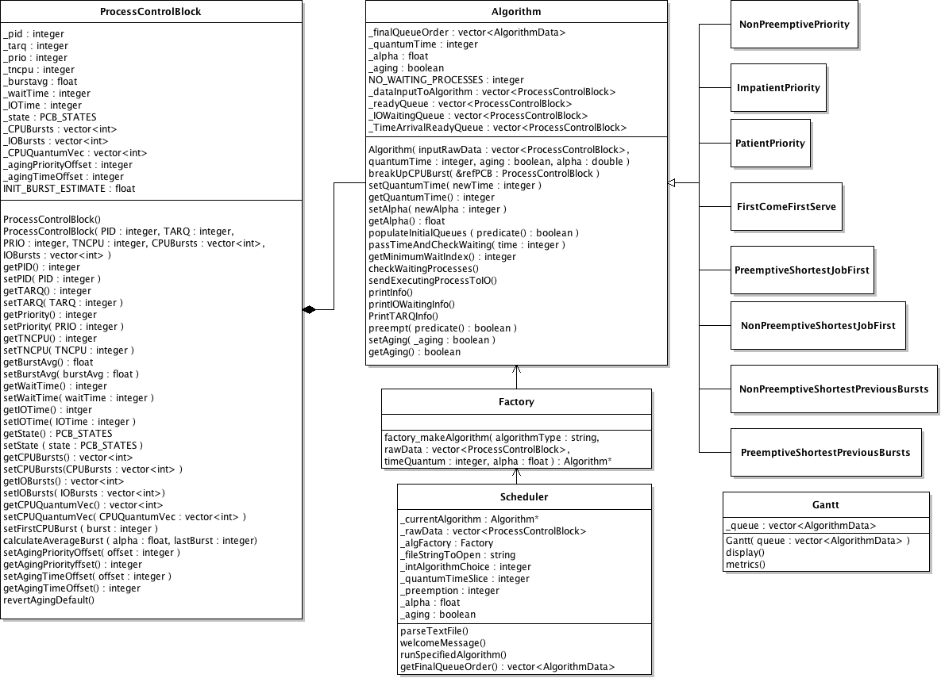
Appendix C - UML Diagram

